ASSIGNMENT 22

PRANEESH SHARMA

B22

21052264

Q1. Write a program to read the contents of a file.

Code:

//this program reads a file and finds the sum of the elements

#include <stdio.h>

int main()

{

    FILE \*fp;

    int a[10], i, sum=0;

    fp=fopen("data.in", "r");

    for(i=0;i<10;i++)

    {

        fscanf(fp,"%d",&a[i]);

        sum+=a[i];

    }

    printf("SUM= %d", sum);

    for(i=9;i>-1;i--)

    printf("\n %d", a[i]);

    fclose(fp);

    return 0;

}

Output:

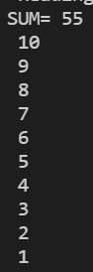

File:



Q2. Write a program to write contents into a file.

Code:

//this program writes the contents of an array into a file

#include <stdio.h>

int main()

{

    FILE \*fp;

    int i, a[10]={2,4,6,8,1,3,5,7,9,0};

    fp=fopen("data.out","w");

    for(i=0;i<10;i++)

        fprintf(fp,"%d ",a[i]);

    fclose(fp);

    return 0;

}

File:



Q3. Write a program to display contents of a file.

Code:

//this program displays contents of a file

#include <stdio.h>

int main()

{

    FILE \*fp;

    char ch;

fp=fopen("demo.txt","r");

    while((ch=fgetc(fp))!=EOF)

        printf("%c",ch);

    fclose(fp);

    return 0;

}

Output:

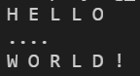

File:

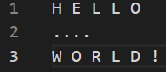

Q4. Write a program to count characters, spaces and newlines of a file.

Code:

//this program counts chars, blank spaces, tabs, and newlines in a file

#include <stdio.h>

int main()

{

    FILE \*fp;

    char ch;

    int noc=0, nob=0, not=0, non=1;

    fp=fopen("demo.txt","r");

    while((ch=fgetc(fp))!=EOF)

    {

        noc++;

        if(ch==' ')

            nob++;

        if(ch=='\t')

            not++;

        if(ch=='\n')

            non++;

    }

fclose(fp);

    printf("\nNo. of characters: %d", noc);

    printf("\nNo. of blanks: %d", nob);

    printf("\nNo. of tabs: %d", not);

printf("\nNo. of lines: %d", non);

    return 0;

}

Output:

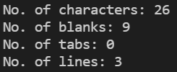

File:

